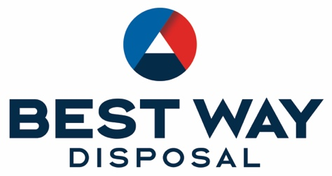

Damage Waiver
Best Way Disposal (“Best Way”) is not responsible for any damage to any structures, surfaces or systems, including, but not limited to: buildings, overhangs, fences, walls, corrals, lawns, driveways, pavement, private roads, sidewalks, curbs, underground plumbing, wells, septic systems, sprinkler systems, or utilities. It is your responsibility to make Best Way aware of any surface conditions or underground utilities which might be affected by delivery of a container or portable restroom. You assume responsibility for damage that may occur due to the size and weight of the delivery vehicle and the size and weight of the container or restroom. You also assume responsibility for damage that may occur due to Customer’s chosen placement of the container or restroom. Best Way shall only be liable for damages to the extent that such damages were caused by Best Way’s gross negligence or willful misconduct.
Customer understands and agrees that this Waiver applies to any and all locations at which Customer requests service.
The person signing this Waiver represents and warrants that he or she is duly authorized and has the legal authority to execute and deliver this Waiver. Signer represents and warrants that the execution and delivery of this Waiver has been duly authorized and that the terms of this Waiver are valid and enforceable.

Name _______________________________________________ Date _________________________
Address of Container Location ____________________________________________________
City ____________________ Zip___________
Customer Signature__________________________

